
DDSS-Business Website


DATA DSS
Website: https://datadss.com/

Marketplace: Codecanyon
Used Technologies: PHP, Laravel, JS, MySQL, Tailwind, HTML, CSS
Demo URL: http://cms.sheulymart.com/

Table of Contents
Introduction 3
Installation 4
Server Requirements 4
Installation Steps 4
Configuration 5
Environment Setup 5
Mail Configuration 6
System Setup 6
Accessing Admin Panel 6
Essential Setup 6
Coulor Setup 7
Header Setup 8
Footer Setup 8
Slider setup 9
Banner setup 9
Home page setup 9
Manage Language 10
Customer Guide 10
Registration 10
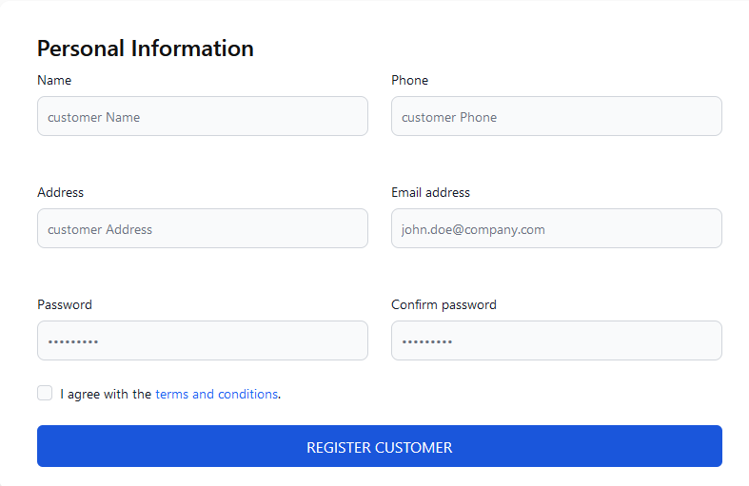 11
Login 11
Customization 13
Theme Customization 13
Adding New Features 13
Support 13
If you face any technical issues or find any bugs please inform us at 14

Introduction
This is a promising ecommerce web application which will be enriched within time. Our prime target is this system will fulfil all of the requirements that you need.

Installation

Server Requirements

To run this script your server must meet the following requiremnets:
- PhP version 8.2+
- MySQL 8.0+
- Node version 18.0+
- mod_rewrite Apache
- BCMath PHP Extension
- Ctype PHP Extension
- JSON PHP Extension
- Mbstring PHP Extension
- OpenSSL PHP Extension
- PDO PHP Extension
- Tokenizer PHP Extension
- XML PHP Extension
- ZipArchive Extension
- Fileinfo Extension
- GD Extension
- SSL certificate

Installation Steps

To install the script follow the steps below.
- Download the file from the codecanyon and extract it. You’ll find a zip file named “install.zip”.
- Upload the Install file to your server and extract it.
- Create a new database and a database user and keep remember the credentials.
- After that, hit your website URL in your browser and it will automatically take you to the installation page.
- Click on the Installation button.
- Now you need to set Database Host, Database Name, Database Username, Database Password, and click Continue.
- Import the SQL file.
- Fill up the information and click Continue.
- That’s all, now use your application.

Configuration

Environment Setup

- Go to your cPanel root directory
- You will find the file named “.env”
- Set the environment on this file
- You can set the credentials directly on this file.

Mail Configuration
Please follow the steps given below and configure your email.

- Go to your cPanel and create a new email
- Keep remember email, password, server and port information.
- Log in to admin panel and go to email configuration.
- Please enter the following value.
  - MAIL DRIVER
  - MAIL HOST
  - MAIL PORT
  - MAIL PASSWORD
  - MAIL FROM ADDRESS
  - MAIL ENCRYPTION

System Setup

Accessing Admin Panel
- Go to login page
- Provide admin credentials
- You will be redirected to admin dashboard

Essential Setup
- Go to the admin dashboard
- Click on the Settings-> System Settings
- Fill up the essential information
- After providing the information click on the save button
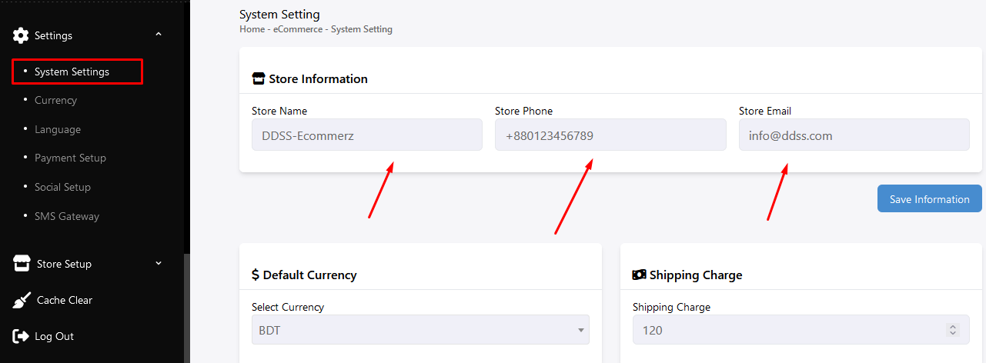

Coulor Setup
- Go to admin dashboard
- Click on the Settings-> System Settings
- Select the colour for the specific section
- Click on the save button
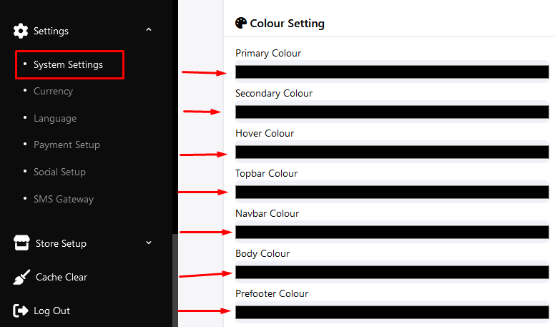

Header Setup
- Go to admin dashboard
- Click on store set up->header
- Upload the header logo
- Add the navbar menu
- Click on the save button
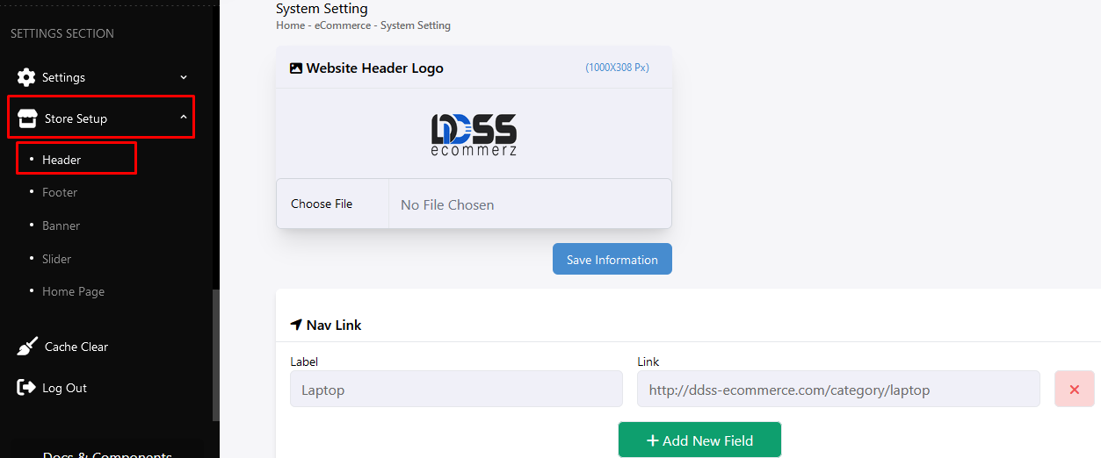

Footer Setup
- Go to admin dashboard
- Click on store set up->footer
- Upload the footer logo
- Add the footer section items
- Click on the save button
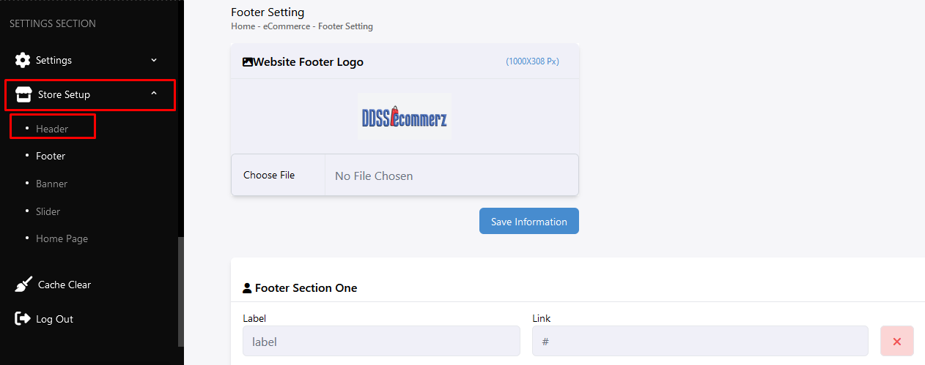

Slider setup
- Login to the admin dashboard
- Click on Store Setup -> Slider
- You will see the slider list
- You can add new slider
- Change the slider status active or inactive
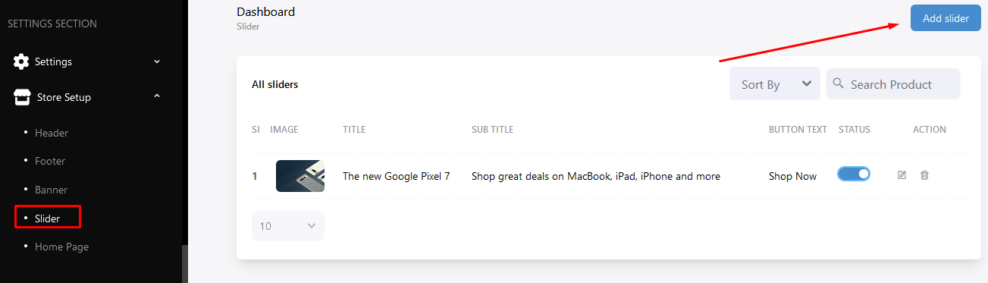

Banner setup
- Login to the admin dashboard
- Click on Store Setup -> Banner
- You will see the banner list
- You can add a new banner
- Change the banner status active or inactive

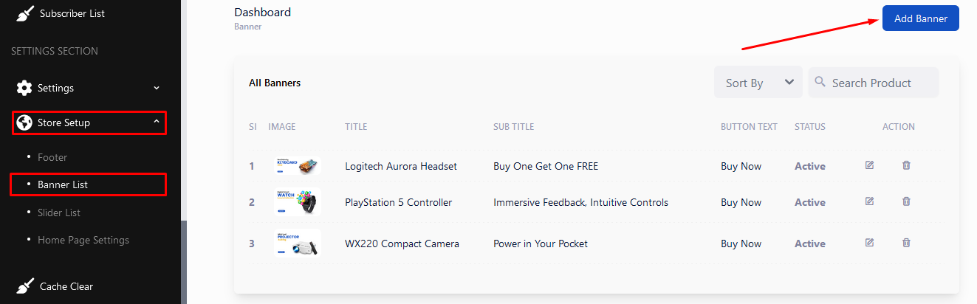

Home page setup
- Login to the admin dashboard
- Click on Store Setup -> Home Page
- Select the products for the specific sections
- Upload images which section needed
- Save the each section separately

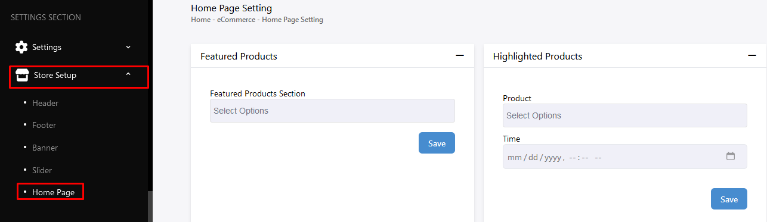

Manage Language
- Login to the admin dashboard
- Click on Settings -> language
- You will see the languages list
- You can add, edit or delete language

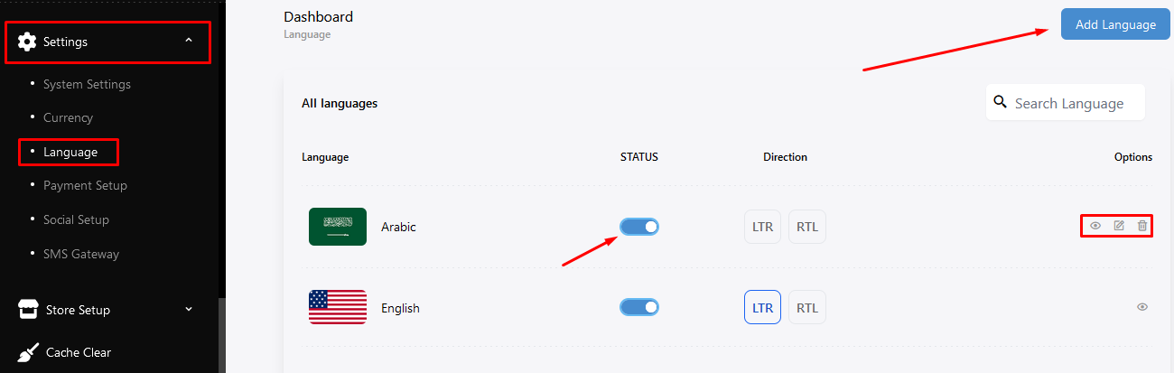

Customer Guide

Registration
- Go to register page
- Enter the required values
- Click on register button
- You are registered customer for the system

Login
- Go to the login page
- Enter the email and passwords
- Click on the login button
- You will be redirected to the customer dashboard
- You can login using social media like Facebook and Google as well
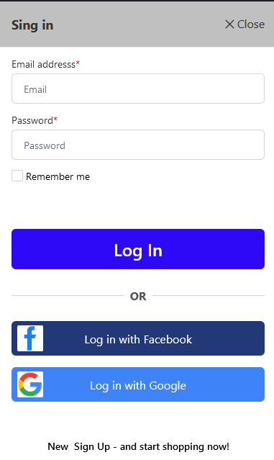

Customization

Theme Customization

We provided setting change options like color change that you can do from the admin panel. Moreover, we provide the full source code so you can customize the code if you want. Even our support team is ready to guide you if you need any help.

N.B. Customized script is no more under support policy. Once you customize the script you can’t update the application anymore. If you do you will lost the customization.

Adding New Features

Adding new features is not under support policy. No worries, we can give you solution to add new features. You can hire developer to customize the script or hire us.
N.B. Customized script is no more under support policy. Once you customize the script you can’t update the application anymore. If you do you will lost the customization.

Support

If you face any technical issues or find any bugs please inform us at developer.datadss@gmail.com. Sometimes it may take long time to response for huge support request. Please be patience, definitely we will respond to you. We are here to provide support and solve the issues of our beloved clients.

